Ever Health Website Training

About

This documentation is a guide for setting up an account and editing account information through Ever Health’s website. The documentation will walk through all steps necessary to get set up with an Ever Health membership account, and address any questions you may encounter along the way.

Creating an Account

To create an account, we must navigate to the “create account” webpage.

1. Navigate to the “create account” page by using the link in the upper right corner of any webpage. This will take you to the form used to create account.

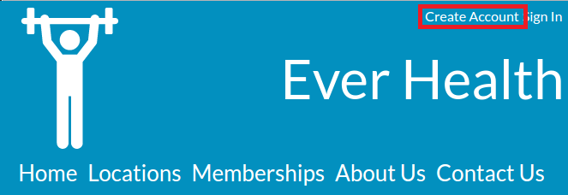

1. Fill out all fields with the appropriate information, note that a valid password requires at least 6 letters and 1 number. You can choose your membership plan with the lowest drop down.

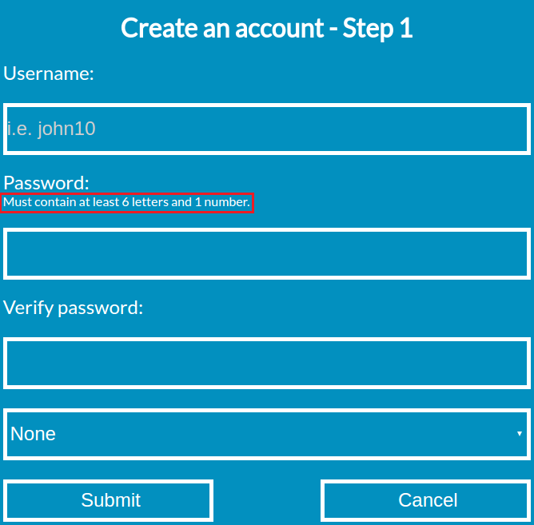

If you enter a username that is already taken, you get an error message stating it:



If you enter an invalid password, you get an error message:



1. After filling out the fields, click submit to continue to the second step.
2. Fill out the personal information fields.

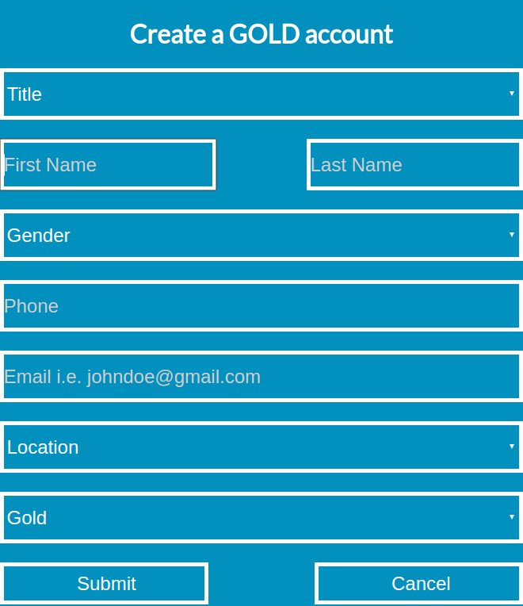

If any field is left blank, an alert will pop up notifying about it. 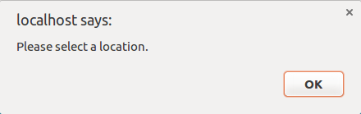

After completing the form, click submit to continue to the final step.

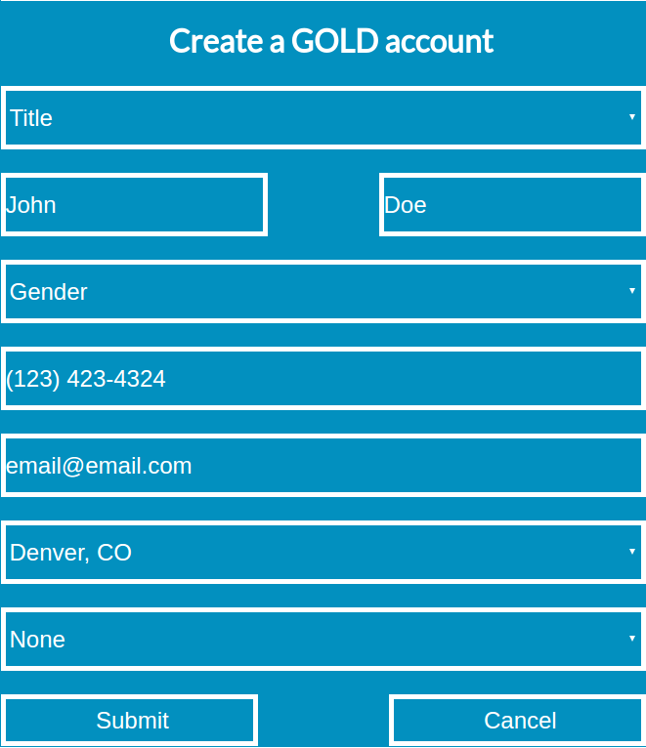

1. Step 3 asks for billing information, once again just fill out the forms with valid information.

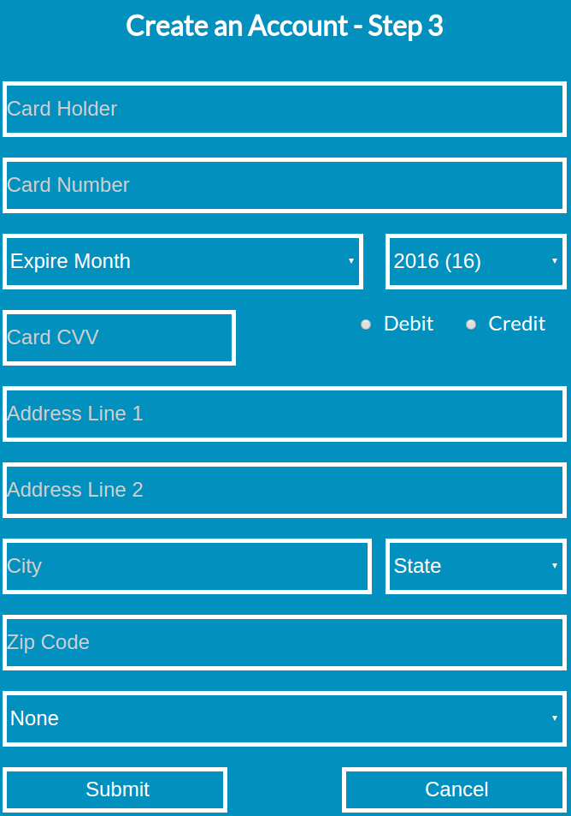

If the form is submitted is incomplete, an alert will pop up:

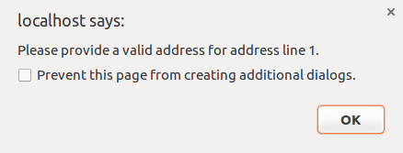

If the form is submitted with invalid information, an alert will show:

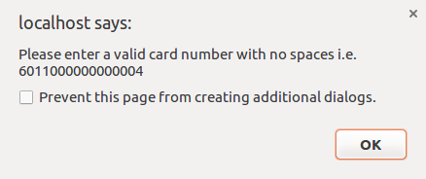

If all information has been filled out and submitted successfully, the browser will redirect to the “My Account” webpage :

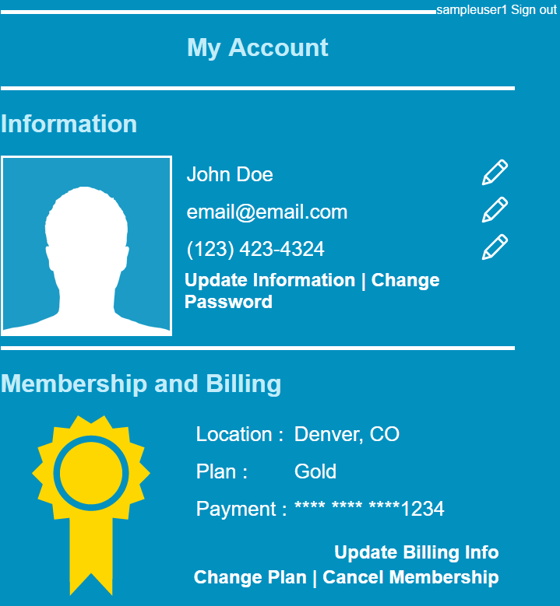

Editing an Account

Account information related to personal and billing can be changed along with the password for the user account.

Update Information

1. Click on the “Update Information” link in the “Information” section of the page, or any of the pencil icons. This takes you to a page that allows the user to update the accounts information.

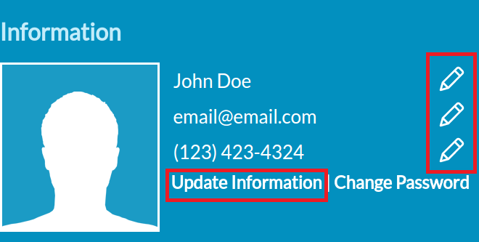

1. A page displaying all the current user information is displayed. The user can edit any one of these fields and click submit to finalize the change:

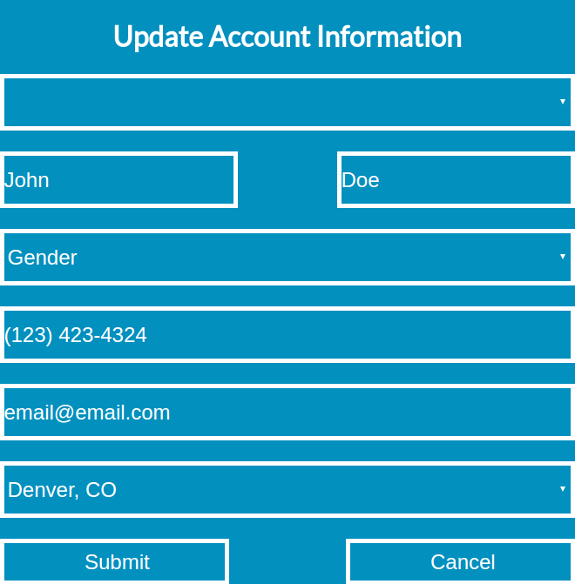

1. After submitting, an alert is displayed if the changes were applied successfully:

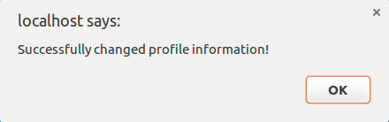

Change Password

Users have the ability to change the password to their account.

1. Click on the “Change Password” link located on the user account page:

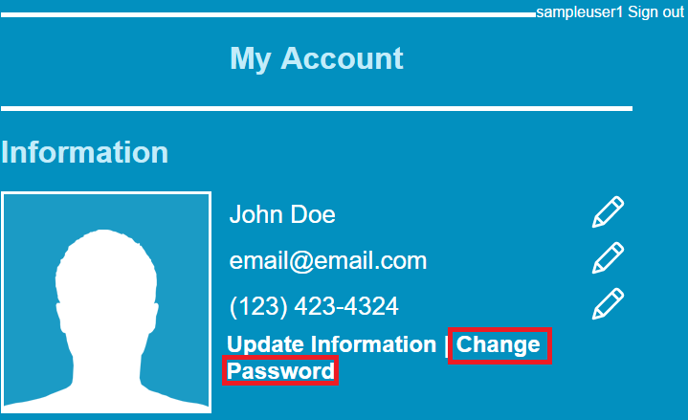

1. Fill out the current password, along with a new password:

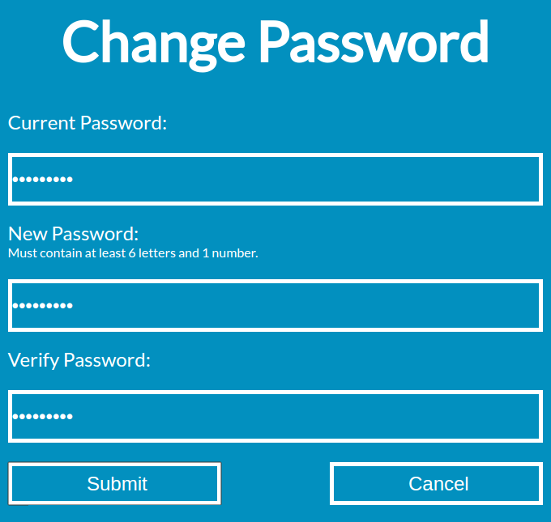

1. Click submit to change the account password.

Update Billing Information

Users have the ability to update their billing information in a very similar way.

1. Navigate to the “Update Billing Info” link:

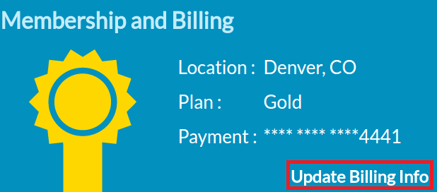

1. In a similar way, all the fields will be filled out with the user’s current information:

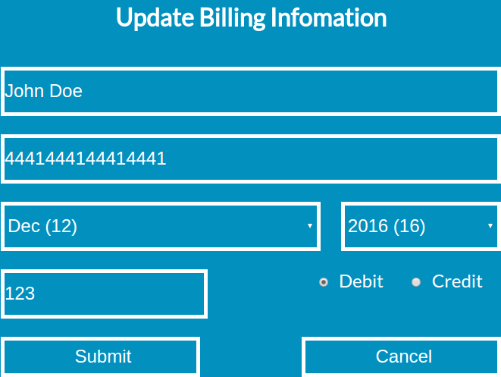

1. Update any information as seen fit. If any fields are filled out incorrectly, an alert will notify the user.
2. Click submit to finalize the changes. An alert will display stating if the changes were applied successfully:

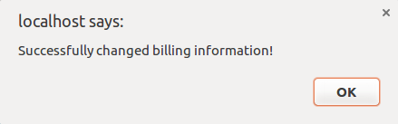

Change Membership

Users have the ability to change their membership plan.

1. Click the “Change Plan” link on the “My Account” page :

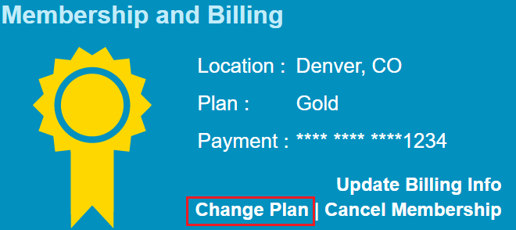

1. Select the plan to change to, a green box will appear around the chosen plan:

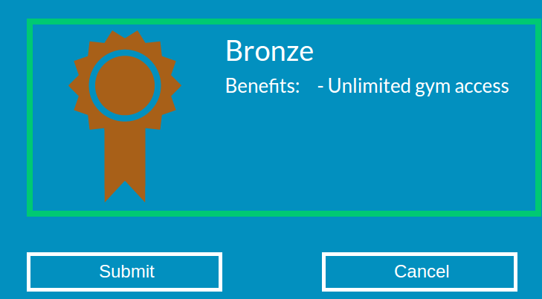

1. Click submit to finalize the changes.
2. An alert will display stating if the changes were successful:

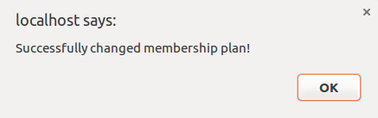

Cancel Membership

Users have the ability to cancel their membership.

1. Click the “Cancel Membership” link in the “Membership and Billing” section:

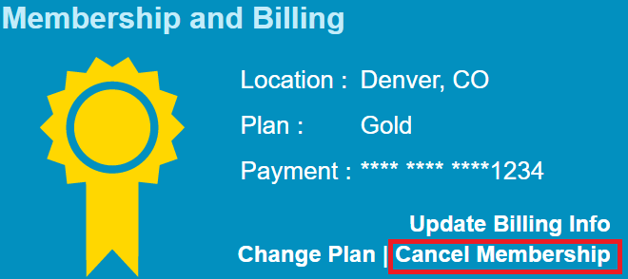

1. A confirmation box will pop up asking “Are you sure you want to cancel your membership?”:

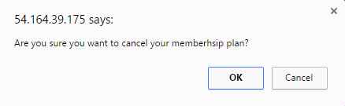

1. Click OK to cancel the membership.